myVITA Administrative Reports: Guide for Chairs to See Evaluations from Previous Years
- Log into myVITA https://www.umsystem.edu/ums/institutional-effectiveness/myvita.
- In the menu screen on the left, select Administration and in the drop-down menu, select Reports.
- Under Administrative Reports, select the last option: Evaluations.

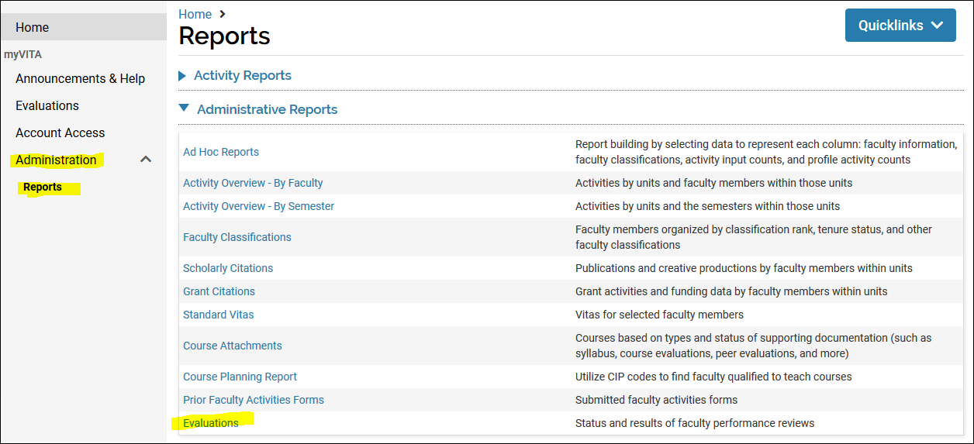
- A screen called Reports will pop up. In the General box, change the dates to reflect January 1 to December 31 of the year the evaluation you wish to see took place (not the year of performance). For example, to review an evaluation that was completed for calendar year 2024, use the dates 2025-1-1 to 2025-12-31. (Note that this box formats dates as YEAR-MONTH-DAY.)
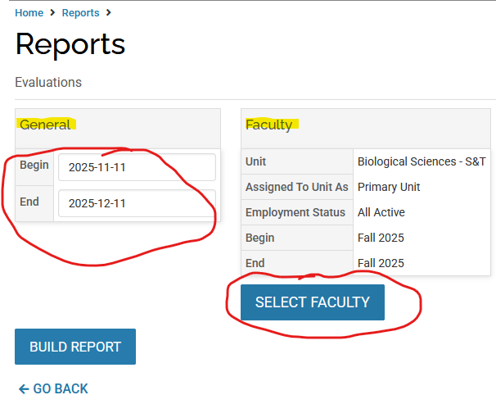
- In the Faculty box, your department name will appear. Click the Select Faculty button and change the Begin date to Spring of the year you used in step four, and the End date to the Fall of the same year. Click on Select Faculty again.
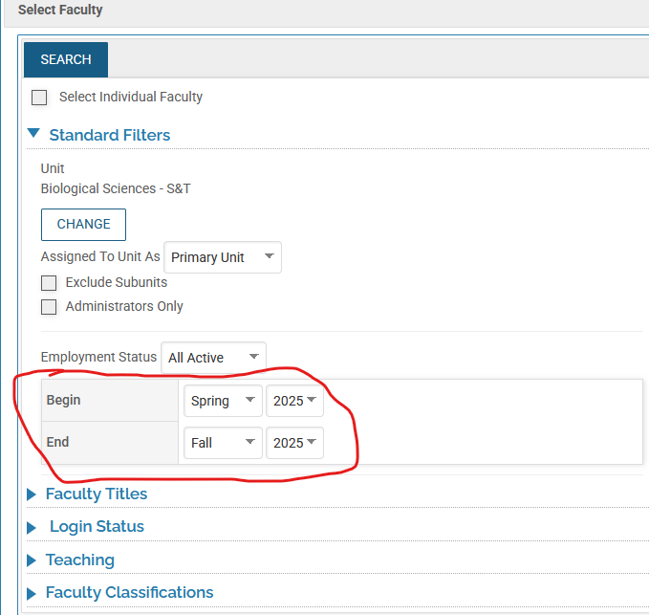

- Click Build Report. You will now see a link to the evaluations for the year(s) you have chosen.

- Click on the blue number under Evaluation Titles next to the unit name. You will see the different documents associated with the annual evaluation process.
- On the line called “Chair evaluation of faculty activities,” click on the blue number under Total Evaluations. This will open the results of that year’s evaluation.

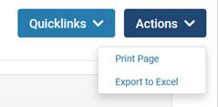
- You will see all the faculty evaluations conducted for the year in question, and can quickly see which faculty exceeded, met, or did not meet expectations without having to open each case individually. You can click the word View (in blue) to open that faculty member’s activity report for that year. You can also export the evaluation information using the Actions button on the top right side of the page. You can export to Excel or print the page.

- You can also save this report by selecting “Add This Page as a Quicklink” in the drop-down option under the Quicklinks box. Just remember to check your dates when you are running your reports.

If you have any questions about this process, email Misty House at housem@mst.edu.

